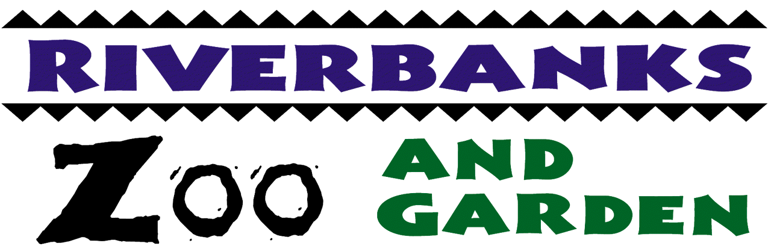
Procurement Services
400 Rivermont Drive, Columbia, SC 29210
Phone: 803-602-0831 Fax: 803-771-8722

STATEMENT OF AWARD

SOLICITATION NUMBER: C16001-10/12/15

PROJECT TITLE: Forklift Maintenance-Term Contract

AWARDED TO: A&L Forklift Services

AMOUNT OF AWARD: See Bid Tabulation (attached)

DATE OF AWARD: October 16, 2015

An actual bidder who is aggrieved in connection with the intended award or award of a contract shall protest to the Procurement Officer in writing within ten (10) calendar days of the date of Intent to Award notice. Protest letter shall state the issues of the protest, specifically listing where the District failed in determining the potential award.

Jessica Monts
Procurement Manager

Date Posted: October 16, 2015

